Topic – Naive Bayes Classifier
Tripti Vishwakarma
Colorado State University Global
Course Code CSC 510 -1
Dr. Isaac Gang
April 27, 2025

Title: Implementation and Results of a Naive Bayes Classifier

Introduction
This paper presents the development and implementation of a Naive Bayes classifier for binary classification tasks. The classifier is implemented in Python and uses the Multinomial Naive Bayes model with Laplace smoothing to handle zero-probability errors. A small dataset is utilized to calculate frequency tables, likelihood tables, posterior probabilities, and predictions. The performance of the classifier is verified through a test dataset and custom input examples. The results demonstrate that the classifier successfully calculates probabilities and predicts the correct class based on the given features.
The Naive Bayes classifier is a probabilistic machine learning model based on Bayes’ theorem. It assumes that features are conditionally independent given the class label. This paper focuses on implementing a Naive Bayes model using Python for binary classification. The specific objectives include:
- Calculating frequency and likelihood tables for feature values.
- Computing posterior probabilities using Bayes’ theorem.
- Handling zero-probability errors with Laplace smoothing.
- Making predictions for test and custom input data.

The implementation is carried out using the Python programming language and relies on pandas for data manipulation.
Methods
Dataset
The dataset consists of two binary features (Feature1, Feature2) and a binary class label (Label). The data is divided into training and testing sets. The training set is used to calculate frequency and likelihood tables, while the testing set is used for validation.

Dataset Sample
Feature1 | Feature2 | Label
0 | 0 | 0
0 | 1 | 1
1 | 0 | 1
1 | 1 | 0
0 | 0 | 0
1 | 0 | 1
1 | 1 | 1
0 | 1 | 0

Algorithm
The following steps outline the Naive Bayes classification process:
- Frequency Table: Counts how often each feature value occurs for each class.
- Likelihood Table: Computes conditional probabilities for each feature value given the class, with Laplace smoothing to handle zero-probability errors.
- Posterior Probabilities: Uses Bayes’ theorem to calculate the probability of each class given the input features.
- Prediction: Assigns the class with the highest posterior probability.

Code Implementation
The Python code for the Naive Bayes classifier is as follows:

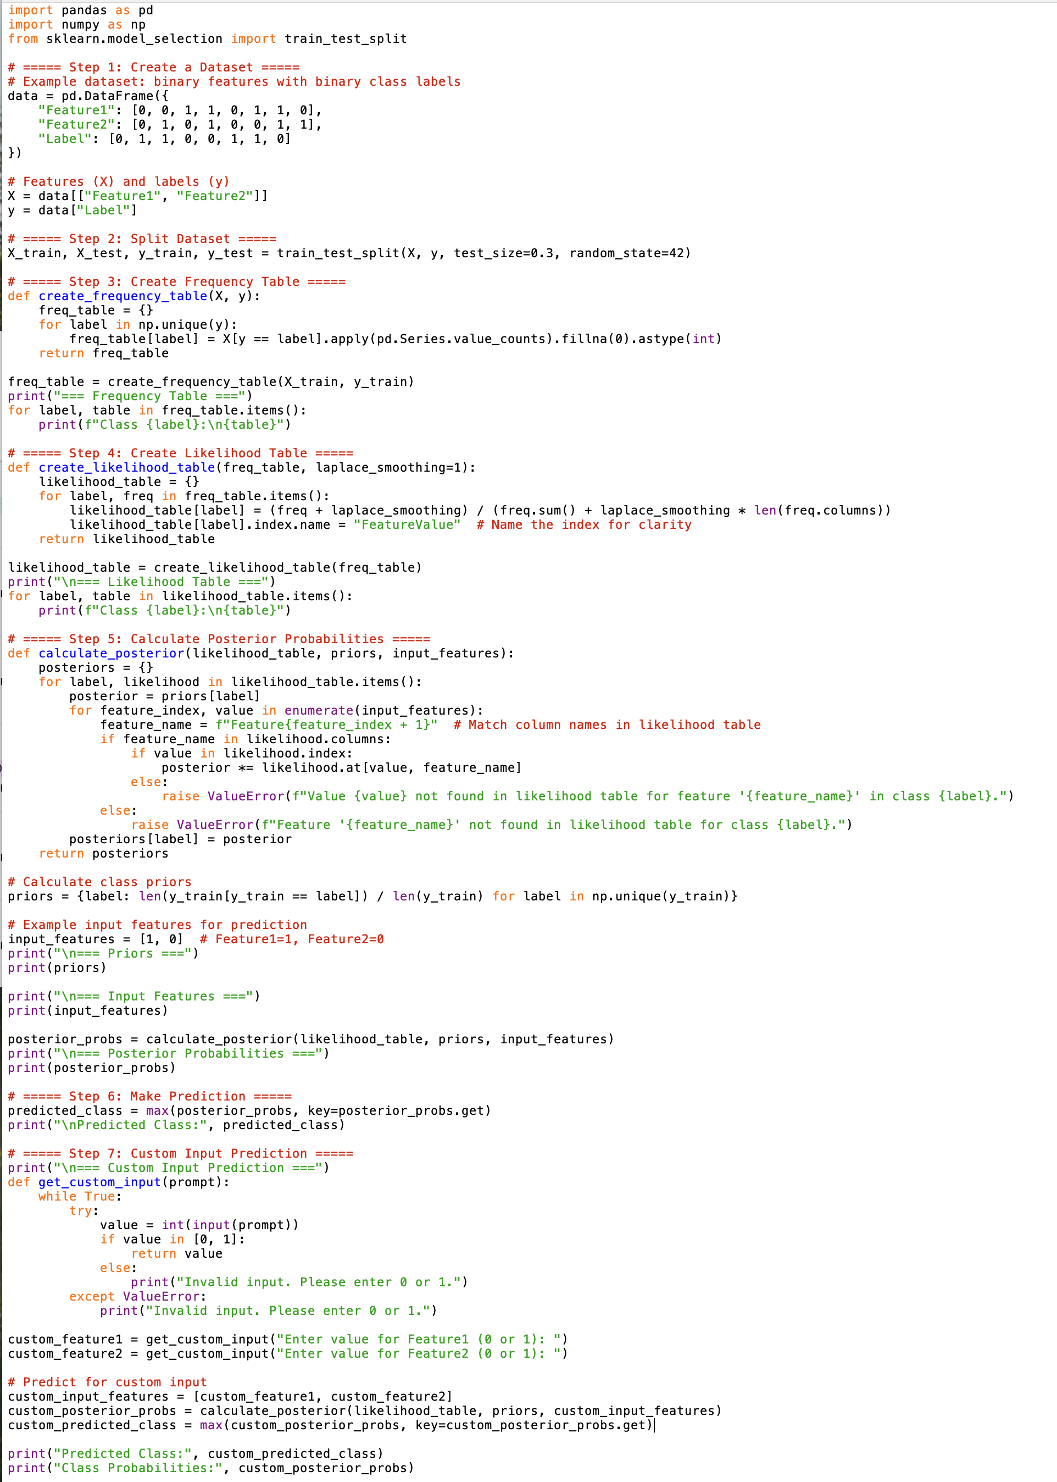

Results
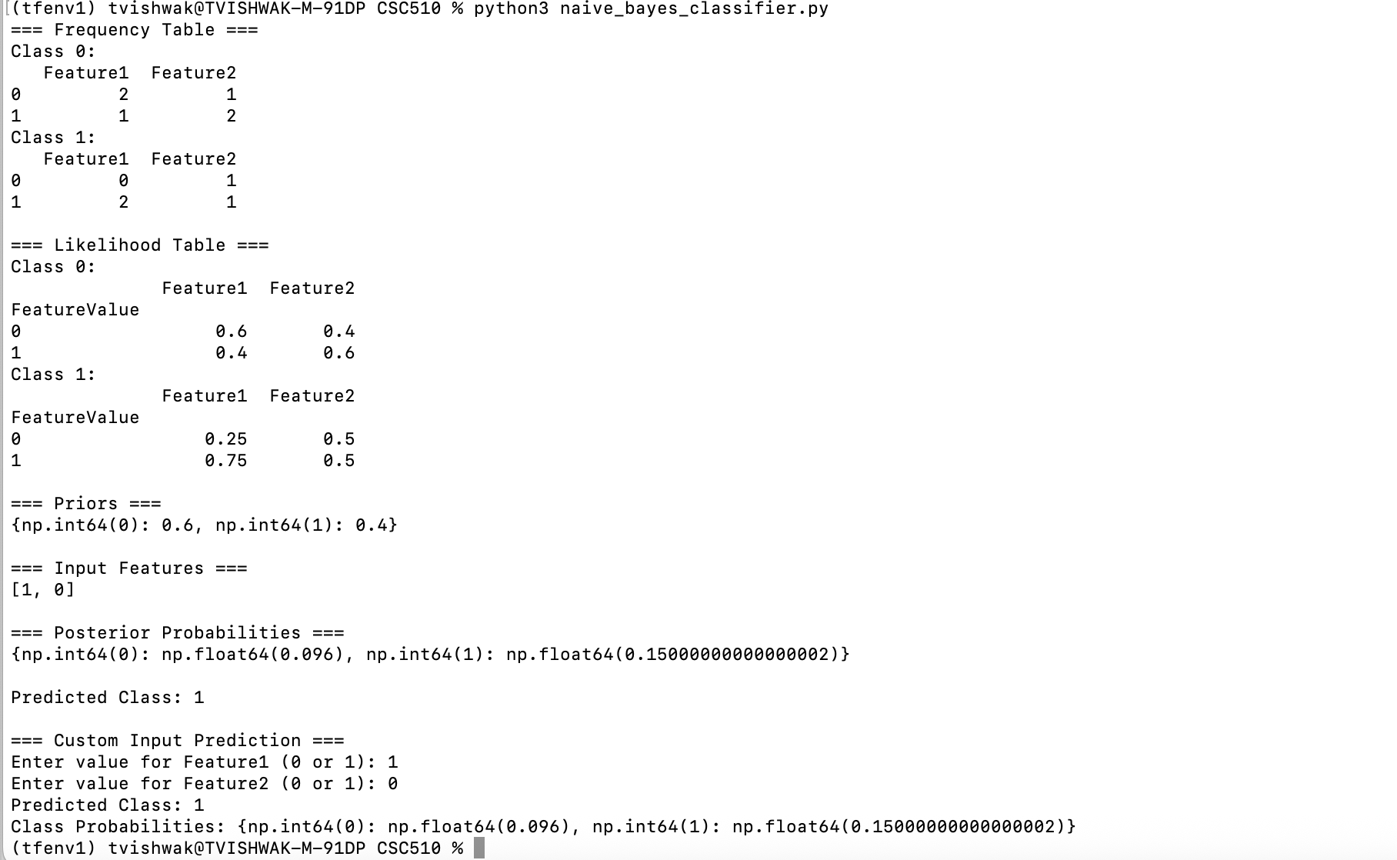

Basic Instructions for testing
When you run the script, the following outputs will be displayed in the terminal:
- Frequency Table: Shows the counts of feature values for each class.
- Likelihood Table: Displays the conditional probabilities for each feature value given the class.
- Priors: Displays the prior probabilities for each class.
- Input Features: The predefined input features for testing (e.g., [1, 0]).
- Posterior Probabilities: Displays the probabilities for each class based on the input features.
- Predicted Class: Shows the class with the highest posterior probability.

Test with Custom Input
After the predefined test, the script will prompt you to enter custom input values for Feature1 and Feature2
Enter 0 or 1 for each feature and press Enter.
The script will calculate and display the following:
- Posterior Probabilities: The probabilities for each class based on the custom input.
- Predicted Class: The class with the highest posterior probability.

References

Introduction to Machine Learning with Python" by Andreas C. Müller and Sarah Guido
https://api.pageplace.de/preview/DT0400.9781449369903_A28070529/preview-9781449369903_A28070529.pdf

Think Bayes: Bayesian Statistics in Python by Allen B. Downey
https://allendowney.github.io/ThinkBayes2/

